**USER MANUAL**

About the project repository:

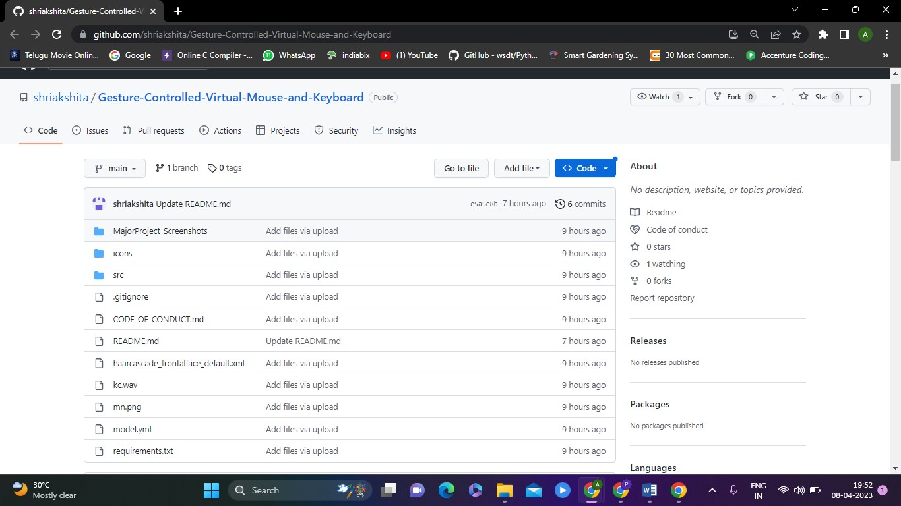

**Fig. 6.1 Directory structure in GitHub**

• **MajorProject_Screenshots:** It is the folder which contains output snapshots of features like voice commands, virtual keyboard, eye movements, gesture controller .

• **icons:** This folder contains icons for Graphical User Interface.

• **src:** It is the folder which includes all code files like Gesture_Controller.py, Gesture_Controller_Gloved.py, proton.py, app.py, eye.py, main.py.

• **haarcascade_frontalface_default.xml:** It is an xml file frontend framework.

• **kc.wav:** It is an audio file which makes click sound.

• **requirements.txt:** It is a file where all the libraries along with their versions are stored.

**Steps to be followed to run the project :**

1. Navigate to the desired folder where you want to save and run the project.

2. Launch the command prompt from the same folder or change the directory in the command prompt to the folder where you want to work.

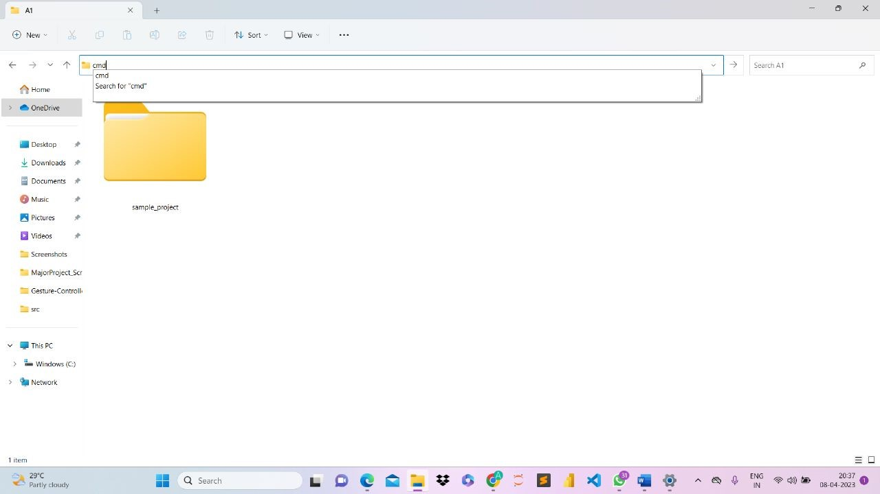

**Fig. 6.2 Directory structure in the local system and accessing cmd**

3. Use the git clone command to save the source code, required files, and folders of the project from the following repository:<https://github.com/shriakshita/Gesture-Controlled-Virtual-Mouse-and-Keyboard.git> You can use the command "git clone <https://github.com/shriakshita/Gesture-Controlled-Virtual-Mouse-and-Keyboard.git>" to save a folder containing all the files and folders of the project to your local system.

4. Use the command "cd Gesture-Controlled-Virtual-Mouse-and-Keyboard" to change the directory to the current working folder.

5. Use the command "pip install -r requirements.txt" to install all the required packages and libraries to run the project.

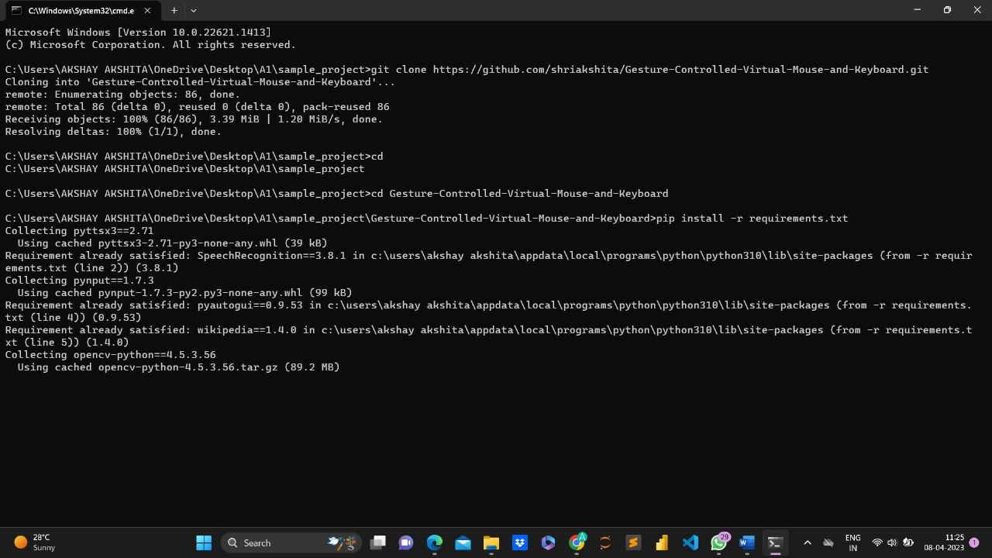**Fig. 6.3 Cloning the github repository and installing all the dependencies required.**

6. To launch the application, use the command "python main.py". This will execute the main Python file and run the application.

7. The application has a graphical user interface (GUI), users can interact with the application by providing inputs through the interface. These inputs could include gestures, voice commands, or other types of input depending on the application's design and functionality.

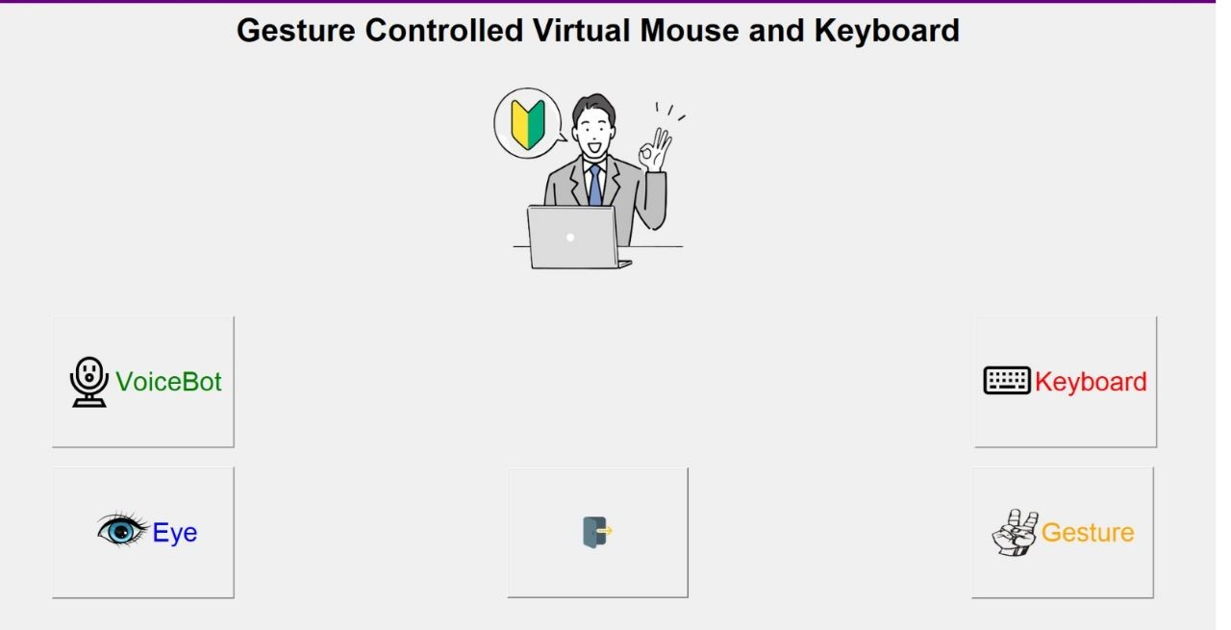**Fig. 6.4 Graphical User Interface**